**In india 80 million people are obese**

**India third in global obesity ranking: excessive body fat accumulation**

**By 2034 11% of our population will be obese**

**🡪Lack of physical activity.**

**🡪Some medications can contribute to weight gain**

**Typically, the term of a patent is 20 years from the filing date of the application. This applies to most countries, including the United States, the European Union, and India**

**Hypoglycemia is a condition where your blood sugar (glucose) level is lower than normal. Glucose is your body's main source of energy.**

**🡪Insulin: Lilly played a pivotal role in the development of insulin, revolutionizing the treatment of diabetes.**

**Insulin:**

* **Role: Insulin acts like a key, unlocking cells to allow glucose to enter.**
* **Action: When blood sugar levels rise after a meal, the pancreas releases insulin.**
* **Effect: Insulin signals cells, especially muscle and liver cells, to absorb glucose from the bloodstream and use it for energy or store it as glycogen.**

**Glucagon:**

* **Role: Glucagon acts as a counterbalance to insulin.**
* **Action: When blood sugar levels drop (for example, between meals or during exercise), the pancreas releases glucagon.**
* **Effect: Glucagon signals the liver to break down stored glycogen into glucose and release it into the bloodstream, raising blood sugar levels.**

**Type 1 Diabetes:(Autoimmune disease)**

* **Pancreas's Role: The immune system mistakenly attacks and destroys the insulin-producing cells in the pancreas.**

**Type 2 Diabetes:**

**With type 2 diabetes, your body either doesn't produce enough insulin or doesn't use insulin properly.**

**Gestational diabetes: Occurs during pregnancy and usually resolves after childbirth.**

**🡪CRISPR-Cas9 is a powerful gene editing tool that has revolutionized the field of biotechnology. It allows scientists to precisely edit the DNA of an organism**

**CRISPR-Cas9 can be used to correct genetic mutations that cause diseases like cystic fibrosis, sickle cell anemia, and Huntington's disease.**

**It can be employed to target and eliminate cancer cells, or to modify immune cells to attack tumors more effectively.**

* **The CRISPR-Cas9 system consists of two key molecules that introduce a change (mutation) into the DNA. These are:**
  + **an enzyme called Cas9. This acts as a pair of ‘molecular scissors’ that can cut the two strands of DNA at a specific location in the genome so that bits of DNA can then be added or removed.**
  + **a piece of RNA called guide RNA (gRNA). This consists of a small piece of pre-designed RNA sequence (about 20 bases long) located within a longer RNA scaffold. The scaffold part binds to DNA and the pre-designed sequence ‘guides’ Cas9 to the right part of the genome. This makes sure that the Cas9 enzyme cuts at the right point in the genome.**
* **The guide RNA is designed to find and bind to a specific sequence in the DNA. The guide RNA has RNA bases that are complementary to those of the target DNA sequence in the genome. This means that, at least in theory, the guide RNA will only bind to the target sequence and no other regions of the genome.**
* **The Cas9 follows the guide RNA to the same location in the DNA sequence and makes a cut across both strands of the DNA.**
* **At this stage the cell recognises that the DNA is damaged and tries to repair it.**
* **Scientists can use the DNA repair machinery to introduce changes to one or more genes in the genome of a cell of interest.**

**🡪Donanemab: A potential treatment for Alzheimer's disease.It was developed by Eli Lilly and Company.**

**A type of protein that is made in the laboratory and can bind to certain targets in the body, such as antigens on the surface of cancer cells. There are many kinds of monoclonal antibodies, and each monoclonal antibody is made so that it binds to only one antigen. Monoclonal antibodies are being used in the diagnosis and treatment of many diseases, including some types of cancer. They can be used alone or to carry drugs, toxins, or radioactive substances directly to cancer cells.Monoclonal antibodies (also called moAbs or mAbs) are proteins made in laboratories that act like proteins called antibodies in our bodies. Antibodies are parts of your**[**immune system**](https://my.clevelandclinic.org/health/articles/21196-immune-system)**. They seek out the antigens (foreign materials) and stick to them in order to destroy them.**

**An epidemic is a disease outbreak that affects many people in a specific region or community. e.g. Ebola outbreak in West Africa,**

**Pandemic**

* **A pandemic is a larger version of an epidemic.**
* **It occurs when an epidemic spreads across multiple countries or continents, affecting a large number of people.**

**Regulatory affairs: Acts as a primary contact between the company and regulatory authorities(govt. bodies)**

**🡪Think of pharmacokinetics as the "journey" of a drug through the body:**

**how a drug moves through the body, including absorption, distribution, metabolism, and excretion.**

**There are typically four main phases a drug goes through inside the body:**

1. **Absorption: This is the process by which the drug enters the bloodstream from the site of administration (e.g., mouth, injection site, skin).**
2. **Distribution: Once in the bloodstream, the drug is distributed throughout the body to different tissues and organs.**
3. **Metabolism: The drug is chemically altered, primarily in the liver, to be more easily eliminated from the body.**
4. **Excretion: The drug and its metabolites are eliminated from the body, mainly through the kidneys in urine or the liver in bile.**

**These four phases are often referred to as the "ADME" process.**

**Pharmacodynamics (PD)**

**Pharmacodynamics, on the other hand, focuses on what the drug does to the body. It explores the biochemical and physiological effects of drugs. Key concepts in pharmacodynamics include:**

1. **Receptor Interactions: How drugs bind to specific receptors in the body to trigger a response.**
2. **Dose-Response Relationship: The relationship between the amount of drug administered and the intensity of the effect.**
3. **Therapeutic Effect: The desired effect of the drug.**
4. **Side Effects: Undesirable effects caused by the drug.**

**In essence, PK tells us how the body handles the drug, while PD tells us how the drug affects the body.**

**A generic drug is a medication that has the same active ingredient as a brand-name drug. Generic drugs are typically much less expensive than brand-name drugs.**

**Active Pharmaceutical Ingredient (API): The main ingredient in a drug that provides the therapeutic effect.**

**Pharmacovigilance** :🡪 understanding, and preventing adverse effects of medicines and vaccines

**IPC stands for Indian Pharmacopoeia Commission. It is an autonomous institution of the Ministry of Health and Family Welfare, Government of India. It is located in Ghaziabad, Uttar Pradesh, India.**

**The primary function of IPC is to set standards for drugs in India. It regularly updates the standards of drugs commonly required for the treatment of diseases. These standards are published in the Indian Pharmacopoeia (IP).**

**A clinical trial is a research study that tests a medicine or therapy in people to help us understand how well it works and how safe it is.**



**Clinical trials**: Clinical trials are a type of research that studies new tests and treatments and evaluates their effects on human health outcomes. People volunteer to take part in clinical trials to test medical interventions including drugs, cells and other biological products, surgical procedures, radiological procedures, devices, behavioural treatments and preventive care.

Clinical trials are carefully designed, reviewed and completed, and need to be approved before they can start. People of all ages can take part in clinical trials, including children.

There are 4 phases of biomedical clinical trials:

* Phase I studies usually test new drugs for the first time in a small group of people to evaluate a safe dosage range and identify side effects.
* Phase II studies test treatments that have been found to be safe in phase I but now need a larger group of human subjects to monitor for any adverse effects.
* Phase III studies are conducted on larger populations and in different regions and countries and are often the step right before a new treatment is approved.
* Phase IV studies take place after country approval and there is a need for further testing in a wide population over a longer timeframe.

Regulatory affairs in the pharmaceutical industry in India is a critical function that ensures the safety, efficacy, and quality of drugs and medical devices before they reach the market. The Department of Pharmaceuticals (DoP) under the Ministry of Chemicals and Fertilizers is the primary regulatory authority in India

The Drugs Controller General (India) is the Central Licensing Authority for Medical Devices in India.

Yes, as per the notification S.O. 648 (E) dated 11.02.2020, all Medical Devices are regulated under the Medical Devices Rules, 2017.

A medical device includes any instrument, apparatus, appliance, implant, material, or other article—whether used individually or in combination, including associated software or accessories—designed specifically for use on humans or animals

Unlike medications or vaccines, which work through chemical or biological actions in the body, medical devices perform their main function through physical means.

Medical devices are used for a range of purposes, including:

* Diagnosing, preventing, or treating diseases or health conditions.
* Helping with or treating injuries or disabilities.
* Investigating or supporting body parts or bodily functions.
* Supporting life functions (like breathing machines).
* Cleaning other medical devices.
* Assisting with birth control.
* **Food and Drug Administration (FDA)US**
* The Food and Drug Administration (FDA) is responsible for protecting the public health by assuring the safety, efficacy, and security of human and veterinary drugs, biological products, medical devices, our nation's food supply, cosmetics, and products that emit radiation. The FDA also provides accurate, science-based health information to the public.

The **European Medicines Agency** (**EMA**) protects and promotes human and animal health by evaluating and monitoring medicines within the European Union (EU)

**Four Applications:**

* + **Investigational New Drug (IND) Application:** This application is submitted to the Central Drugs Standard Control Organization (CDSCO) to initiate clinical trials for a new drug. The IND application includes preclinical data, proposed clinical trial protocols, and plans for manufacturing and quality control.
  + **New Drug Application (NDA):** This application is submitted to the CDSCO after successful completion of clinical trials to seek approval for marketing a new drug.

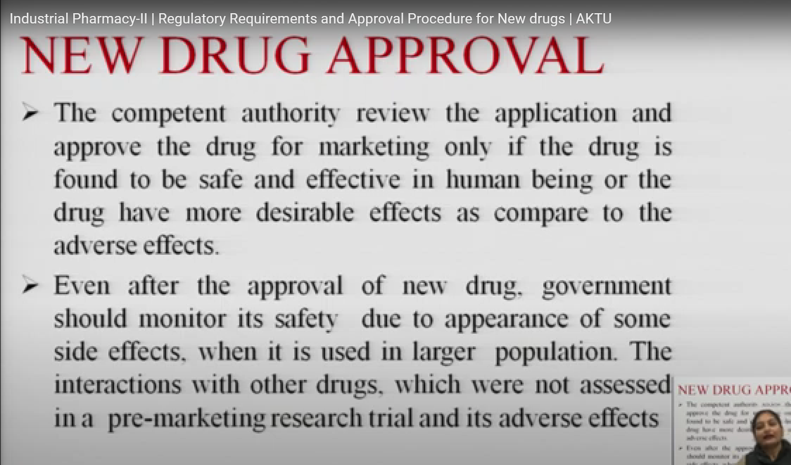

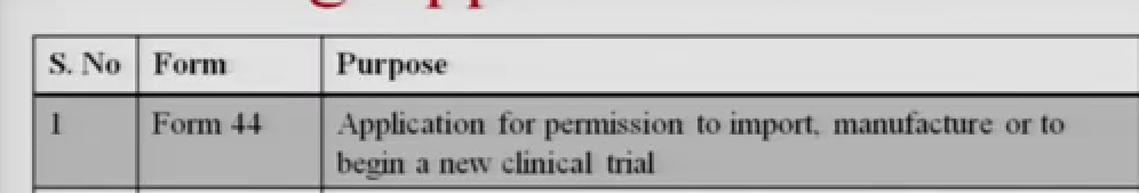

* + **Abbreviated New Drug Application (ANDA):** This application is used for generic drugs.
  + **Biological Product Application (BPA):** This application is used for biological products, such as vaccines, blood products, and recombinant DNA-derived products.

**The specific requirements for each type of application can be found in the Drugs and Cosmetics Rules, 1945**

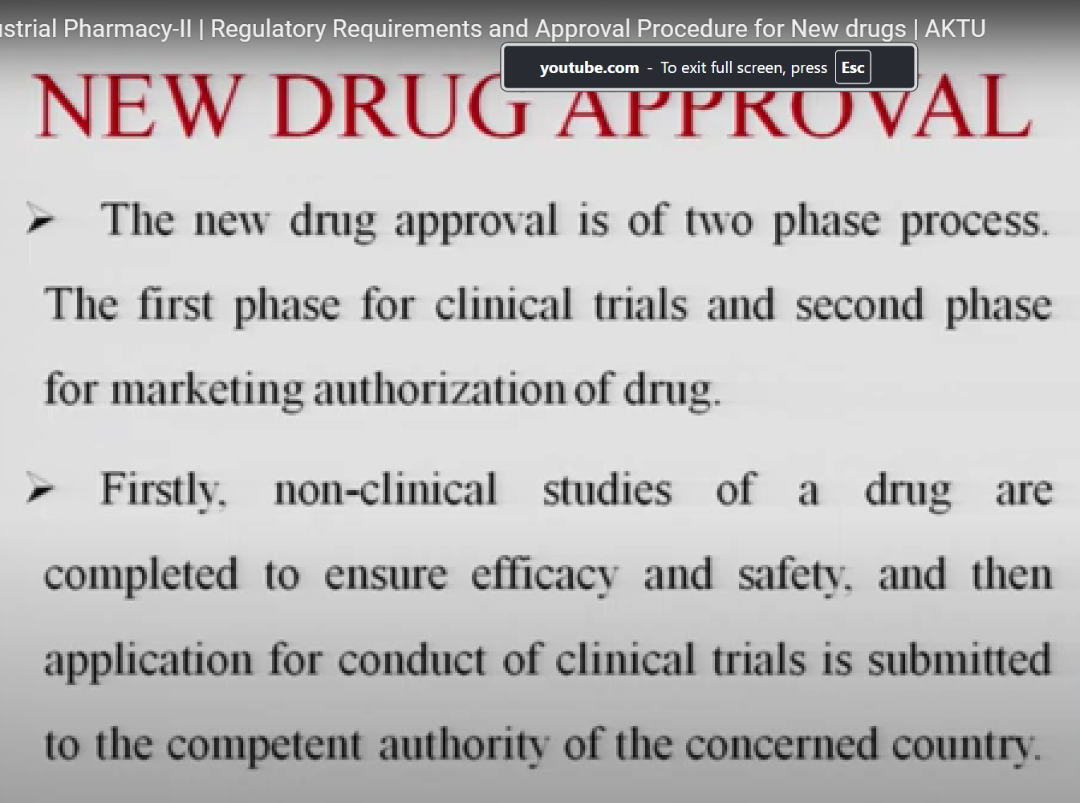

* **Central Drugs Standard Control Organization**
* **Directorate General of Health Services**
* **Ministry of Health & Family Welfare**
* **Government of India**

**CDSCO FUNCTION:** Regulatory control over the import of drugs, approval of new drugs and clinical trials

Medical Devices are classified into four class based on the risk parameter as specified in Part I of the First Schedule of the Medical Devices Rules, 2017, as under:

* + Low risk - Class A; • **Condoms**: **Class A** (Low risk)

**Class A (Low Risk)**

1. **Definition:** Devices that pose **minimal risk** to the patient and are generally non-invasive.
2. **Characteristics:** These devices have a **low potential to harm** the user and are subject to the **least regulatory control**.
3. **Examples:**
   * Thermometers
   * Bandages and dressings
   * Non-invasive diagnostic devices like stethoscopes
   * Surgical instruments like forceps and scissors
   * Examination gloves
   * Low moderate risk- Class B; **Class B (Low to Moderate Risk)**
   * **Definition:** Devices that pose a **higher risk** than Class A devices but still have a **moderate risk** to the user.
   * **Characteristics:** These devices may have **invasive characteristics**, but the risk is generally **minimal** or **well-controlled**.
   * **Examples:**
   * Infusion pumps
   * Blood pressure monitor
   * Surgical drapes
   * Contact lenses (non-invasive but may carry some risk)
   * Examination gloves

* + Moderate high risk- Class C; **Intrauterine Devices (IUDs)**: **Class C** (Moderate risk) E.G. Copper T (copper is toxic to sperm )
  + The classification of **medical devices in India** is governed by the **Medical Devices Rules, 2017**, which came into effect under the regulatory framework of the **Central Drugs Standard Control Organization (CDSCO)**. The rules classify medical devices based on their **risk** level, intended use, and duration of contact with the human body. The classification helps in determining the level of regulation and oversight required for each device.
  + **Classification of Medical Devices in India According to Medical Devices Rules, 2017**
  + Medical devices are classified into **four classes**: **Class A**, **Class B**, **Class C**, and **Class D**. These classes are based on the **degree of risk** posed by the device and its intended purpose.
  + **Class A (Low Risk)**
  + **Definition:** Devices that pose **minimal risk** to the patient and are generally non-invasive.
  + **Characteristics:** These devices have a **low potential to harm** the user and are subject to the **least regulatory control**.
  + **Examples:**
  + Thermometers
  + Bandages and dressings
  + Non-invasive diagnostic devices like stethoscopes
  + Surgical instruments like forceps and scissors
  + Examination gloves
  + **Regulatory Requirements:**
  + Manufacturers of **Class A** devices are required to obtain a **license** for manufacturing or selling the device. The licensing process is relatively straightforward compared to higher-risk devices.
  + **Class B (Low to Moderate Risk)**
  + **Definition:** Devices that pose a **higher risk** than Class A devices but still have a **moderate risk** to the user.
  + **Characteristics:** These devices may have **invasive characteristics**, but the risk is generally **minimal** or **well-controlled**.
  + **Examples:**
  + Infusion pumps
  + Blood pressure monitors
  + Surgical drapes
  + Contact lenses (non-invasive but may carry some risk)
  + Examination gloves
  + **Regulatory Requirements:**
  + Devices in **Class B** require a **license** for manufacture, sale, or import, and the manufacturer is subject to additional scrutiny to ensure the safety and effectiveness of the device.
  + **Class C (Moderate to High Risk)**
  + **Definition:** Devices that present a **higher level of risk** to the user and require more stringent regulatory controls.
  + **Characteristics:** These devices are typically **invasive** or are used for **critical procedures**.
  + **Examples:**
  + Intrauterine devices (IUDs)
  + Dialyzers (used in kidney dialysis)
  + Defibrillators
  + Bone fixation plates and screws
  + Ventilators
  + Contact lenses (invasive types like those used for vision correction

* + High risk- Class D " **Class D (High Risk)**
  + **Definition:** Devices that pose the **highest risk** to patients and require the **most stringent regulatory control**.
  + **Characteristics:** These devices are often **life-sustaining**, **implantable**, or **critical** for the health of the patient.
  + **Examples:**
  + Pacemakers
  + Heart valves
  + Cochlear implants
  + Artificial joints (e.g., hip replacements)
  + Spinal fixation devices
  + Stents

"Active medical device" means a medical device, the operation of which depends on a source of electrical energy or any other source of energy other than the energy generated by human or animal body or gravity;

Pacemakers(A **pacemaker** is a small medical device implanted in the chest or abdomen to help control abnormal heart rhythms. It works by sending electrical pulses to the heart to maintain a normal heartbeat when the heart’s own electrical system isn’t working properly.)

pulse oximeters: A **pulse oximeter** is a small, non-invasive medical device that measures the oxygen saturation level (SpO₂) in the blood

**1. Central Licensing Authority (CLA)**

The **CLA** is the central regulatory body under CDSCO, primarily responsible for:

* Licensing higher-risk medical devices (Classes C and D), which include critical devices that are life-supporting or life-sustaining.
* Overseeing devices that require higher regulatory control due to their potential risk to the patient.
* Evaluating and granting import licenses for medical devices brought into India.
* Conducting clinical trials and reviewing applications for new, high-risk devices.
* Monitoring the post-market surveillance for these higher-risk devices to ensure safety and effectiveness.

**Key Differences Between CLA and SLA**

| **Aspect** | **CLA (Central Licensing Authority)** | **SLA (State Licensing Authority)** |
| --- | --- | --- |
| **Scope** | High-risk devices (Classes C and D) | Low to moderate-risk devices (Classes A and B) |
| **Jurisdiction** | Central or national level | State level |
| **Regulatory Authority** | CDSCO (central agency) | State drug regulatory offices |
| **Responsibilities** | Licensing, import approval, clinical trials, post-market surveillance for high-risk devices | Licensing, inspection, and regulation of manufacturing and sale of low-risk devices |
| **Examples of Devices** | Pacemakers, heart valves, implants, ventilators | Thermometers, syringes, blood pressure monitors |

**2. State Licensing Authority (SLA)**

The **SLA** operates at the state level and is responsible for:

* Licensing lower-risk medical devices (Classes A and B), which include non-invasive and low-risk devices.
* Granting manufacturing and distribution licenses for devices manufactured within the respective state.
* Inspecting manufacturing facilities to ensure compliance with regulatory standards for lower-risk devices.
* Overseeing local distribution and supply chains for these devices.

Examples of Class A and B devices include thermometers, tongue depressors, and syringes.

**1. Invasive Medical Devices**

* **Definition:** Devices that are introduced into the body, either through a break in the skin, through a body orifice (like the mouth or nose), or into internal tissues.
* **Examples:**
  + **Surgical tools** like scalpels and forceps
  + **Catheters** (used to drain fluids or administer medication)
  + **Endoscopes** (inserted through the mouth or other openings to examine internal organs)
  + **Implants** (like pacemakers or joint replacements)

**2. Non-Invasive Medical Devices**

* **Definition:** Devices that do not penetrate the body or require insertion into internal areas.
* **Examples:**
  + **External diagnostic devices** like pulse oximeters and blood pressure monitors
  + **Imaging devices** like X-rays and MRI scanners
  + **Wearable devices** that monitor health, like fitness trackers
  + **Supportive devices** like hearing aids and eyeglasses

Non-invasive devices are often used for monitoring or external support, posing a lower risk to the patient since they don’t physically enter the body.

**. Passive Medical Devices**

* **Definition:** Devices that don’t require an external energy source and work solely through physical interaction or structural support.
* **Examples:**
  + **Bandages and dressings** (used for wound care)

**5. Implantable Medical Devices**

* **Definition:** Devices that are surgically placed inside the body and designed to stay in place long-term.
* **Examples:**
  + **Orthopedic implants** (such as knee or hip replacements)
  + **Heart devices** like pacemakers and defibrillators
  + **Dental implants**
  + **Breast implant**

**Condoms** are classified as **medical devices** under the category of **"Contraceptive Devices"**. They are designed to prevent pregnancy and reduce the risk of sexually transmitted infections (STIs)

**PDB**🡪 Protein Data Bank (Structural database)

* + Contains 3d structure of proteins